W08 Articulate
Inheritance is one of the best ways to simplify your programming so it can be changed or improved. The concept allows you to have many classes with shared attributes. These shared attributes are kept in a base class and inherited by subclasses. These subclasses will have all the attributes and methods within the base class without the lines of code written into them. This leaves the subclasses to be incredibly simple and contain an easy layout with their unique attributes and methods. This simplicity allows easy modification to old programs as well without breaking the code. In my inheritance prove program, I exceeded expectations by adding a new subclass to the program.
Base class:
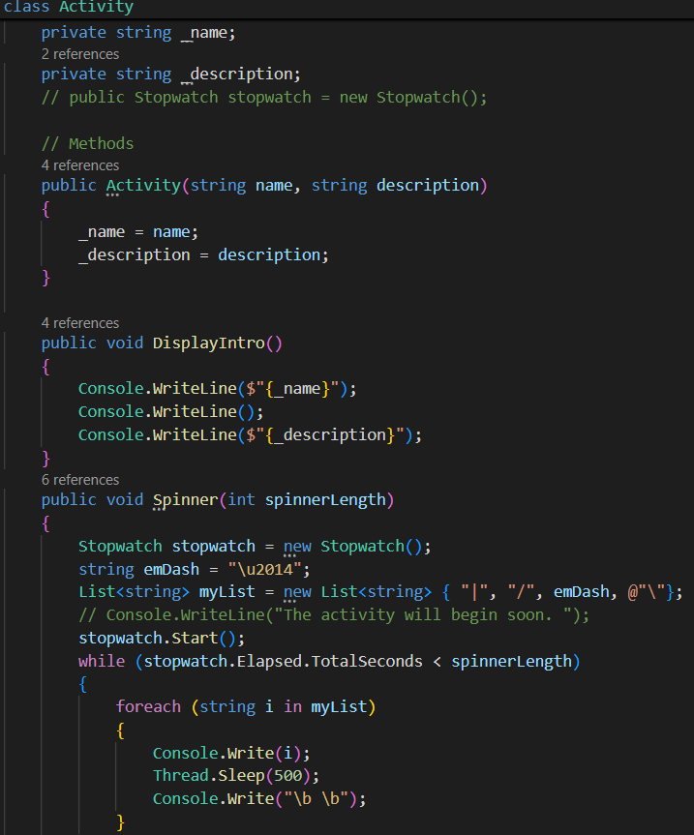
The new activity I added was simple and easy, because it only needed a method after it inherited from the base class. I was able to use the other methods like “Spinner()” to really simplify the subclass.
New Subclass:
